1.

CREATE TABLE store_reps (

rep_ID NUMBER(5) PRIMARY KEY,

last VARCHAR2(15),

first VARCHAR2(10),

comm CHAR(1) DEFAULT 'Y'

);

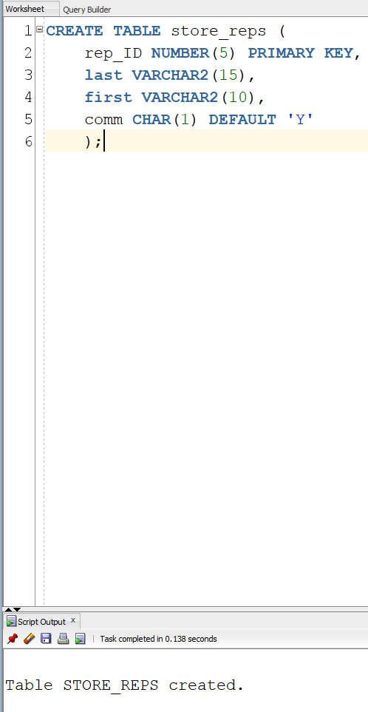

2.

ALTER TABLE store_reps

MODIFY (

Last CONSTRAINT store_reps_Last_nn NOT NULL,

First CONSTRAINT store_reps_First_nn NOT NULL);

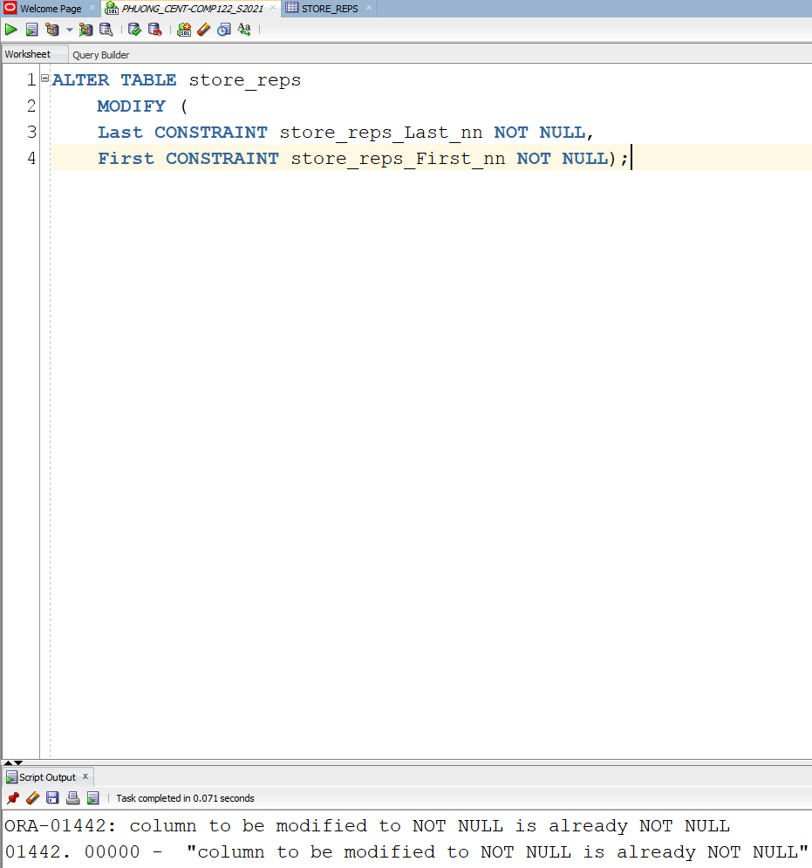

3.

AFTER TABLE store_reps

ADD CONSTRAINT store_reps_comm_ck CHECK (comm IN('Y','N'));

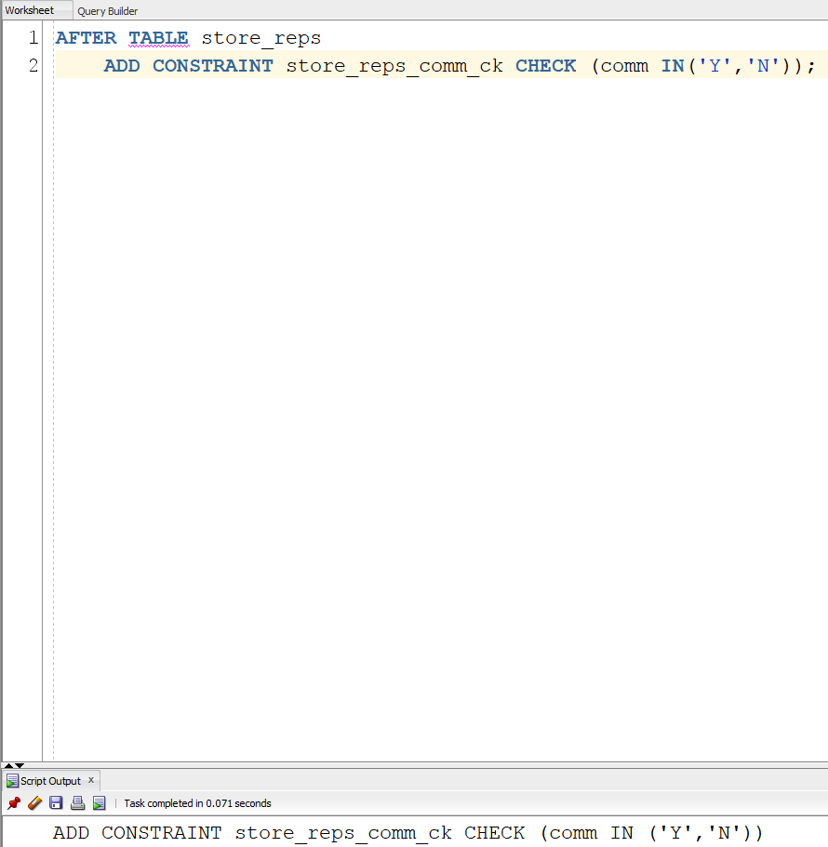

4.

AFTER TABLE store_reps

ADD (base_salary NUMBER(7,2)

CONSTRAINT store_reps_base_salary_ck CHECK (base_salary > 0));

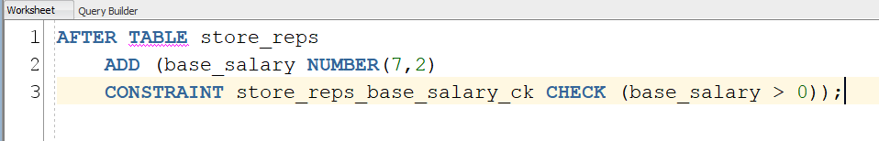

5.

CREATE TABLE book_stores(

store_id NUMBER(8),

name VARCHAR2(30) NOT NULL,

contact VARCHAR2(30),

rep_id VARCHAR2(5),

CONSTRAINT book_stores_id_pk PRIMARY KEY (store_id),

CONSTRAINT book_stores_name_uk UNIQUE (name));

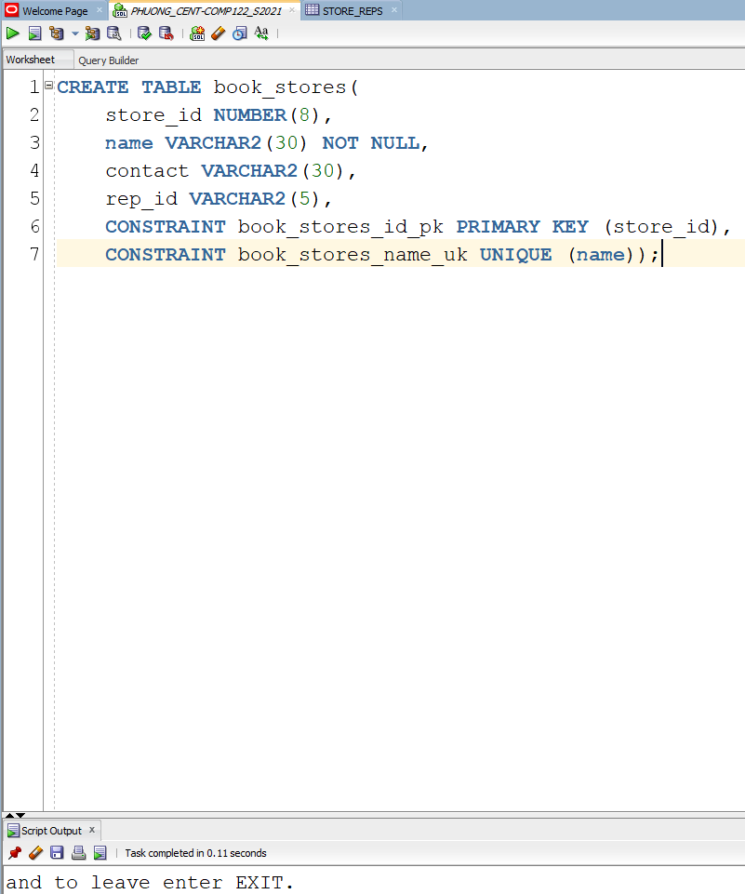

6.

AFTER TABLE book_stores

MODIFY (rep_id NUMBER(5))

ADD CONSTRAINT book_stores_rep_id_fk FOREIGN KEY(rep_id)

REFERENCES store_reps (rep_id);

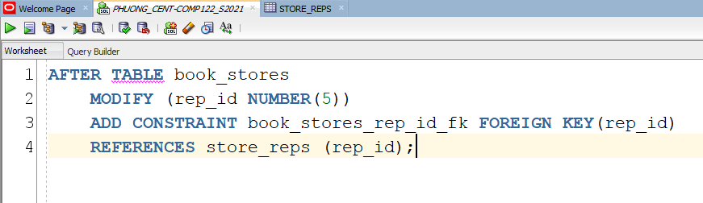

7.

AFTER TABLE book_stores

DROP CONSTRAINT bookstores_rep_id_fk;

AFTER TABLE book_stores

ADD CONSTRAINT bookstore_rep_id_fk FOREIGN KEY (rep_id),

REFERENCES store_reps (rep_id) ON DELETE CASCADE;

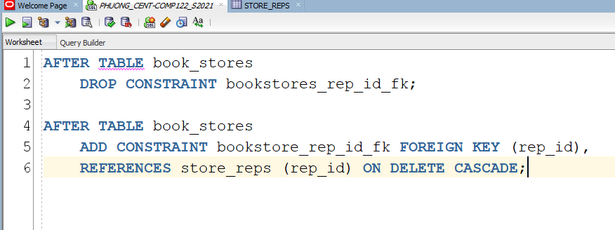

8.

CREATE TABLE rep_contracts (

store_id NUMBER(8),

name VARCHAR2(5),

quarter CHAR(3),

rep_id NUMBER(5),

CONSTRAINT rep_contracts_pk PRIMARY KEY (store_id, quarter, rep_id),

CONSTRAINT rep_contracts_store_id_fk FOREIGN KEY (store_id)

REFERENCES book_stores (store_id),

CONSTRAINT rep_contracts_rep_id_fk FOREIGN KEY(rep_id)

REFERENCES store_reps (rep_id) );

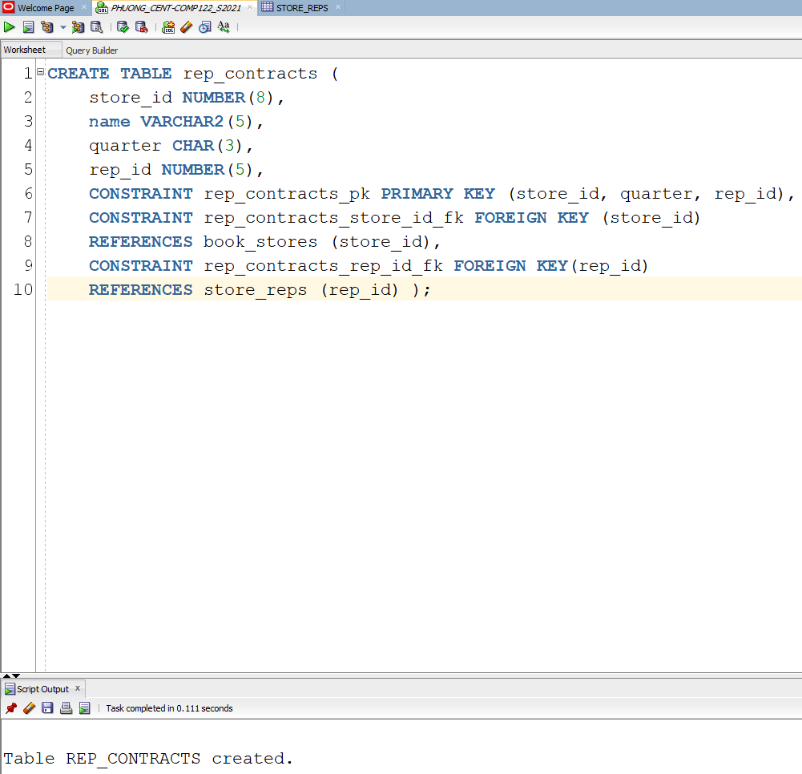

9.

SELECT constraint_name, search_condition

FROM user_constraints

ORDER BY table_name;

select constraint_name from user_constraints where table_name='STORE_REPS';

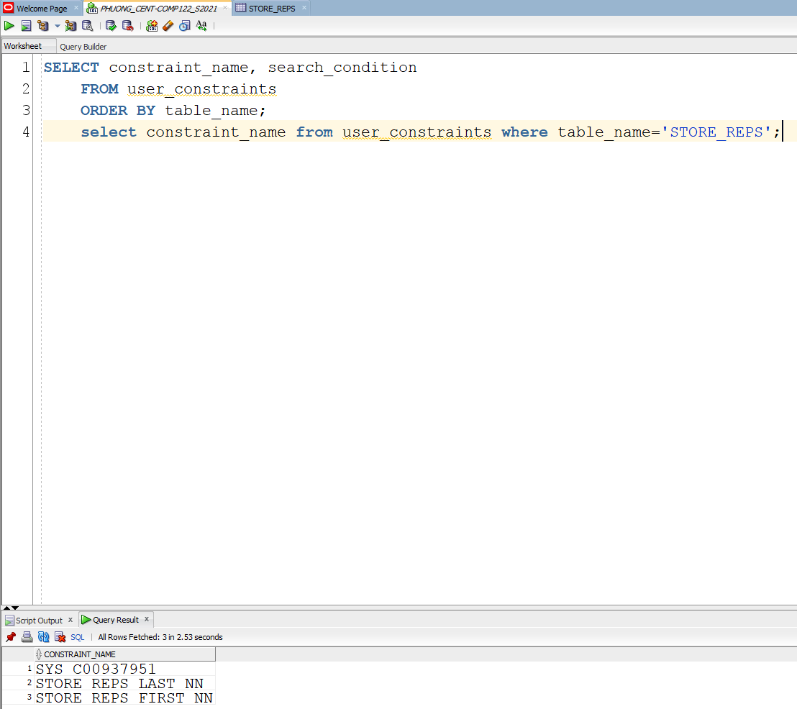

10.

AFTER TABLE store_reps

DISABLE CONSTRAINT store_reps_base_salary_ck;

ALTER TABLE store_reps

ENABLE CONSTRAINT store_reps_base_salary_ck;